台積電x彰化女中STEM人才培育獎學金申請辦法

- 關於台積電STEM人才培育獎助:
台積電為鼓勵暨培育高中生投入科學(Science)、技術(Technology)、工程(Engineering)、數學(Mathematics)領域，特設立此獎助學金。
- 獎助金額及名額:
- 每位受獎者於獲獎後可獲得兩年，每年各新台幣兩萬元之獎學金，惟受獎後若發生轉學、休學或轉班群、評定學習狀況或品行不佳者，取消次年受獎資格。
- 每學年度至多15名受獎者。
- 申請資格:
- 高二、高三C群學生、雙語實驗班與數理資優班修習C群學生。
- 努力向學、品行良好、在校無不良紀錄。
- 成績標準
- 高二：前一學年度各科學業成績及格，且總平均80分以上。
- 高三：
第一階段：原領取生，仍須提出申請，且學期成績75分以上。
第二階段：若有轉群等無法續領獎者出現，教務處將擇期辦理申請。
- 參與校內外科學相關競賽、活動、社團等，列入評核考量。
- 參與教育部主辦、委辦各級科學相關活動，列入評核考量。
- 低收入戶、急難救助、身心障礙者列入考慮。
- 申請方式:於9月22日(一)前備妥相關申請資料送至教務處設備組。

- 受獎義務:
- 填寫台積電提供的「未來動向調查問卷」。
- 第一年之受獎學生須在學期結束前註冊半導體雲端學院，並於畢業前取得結業證書。
- 積極參與台積電舉辦的校園活動或課程。

附件一
台積電x彰化女中STEM人才培育獎學金申請表
一、申請人基本資料
班級 |  | 座號 |  | 姓名
聯絡電話
Email
導師簽名
二、請列出前一學年學業平均成績、簡要自述及曾/目前正參與之科學競賽或活動
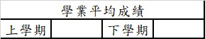 | 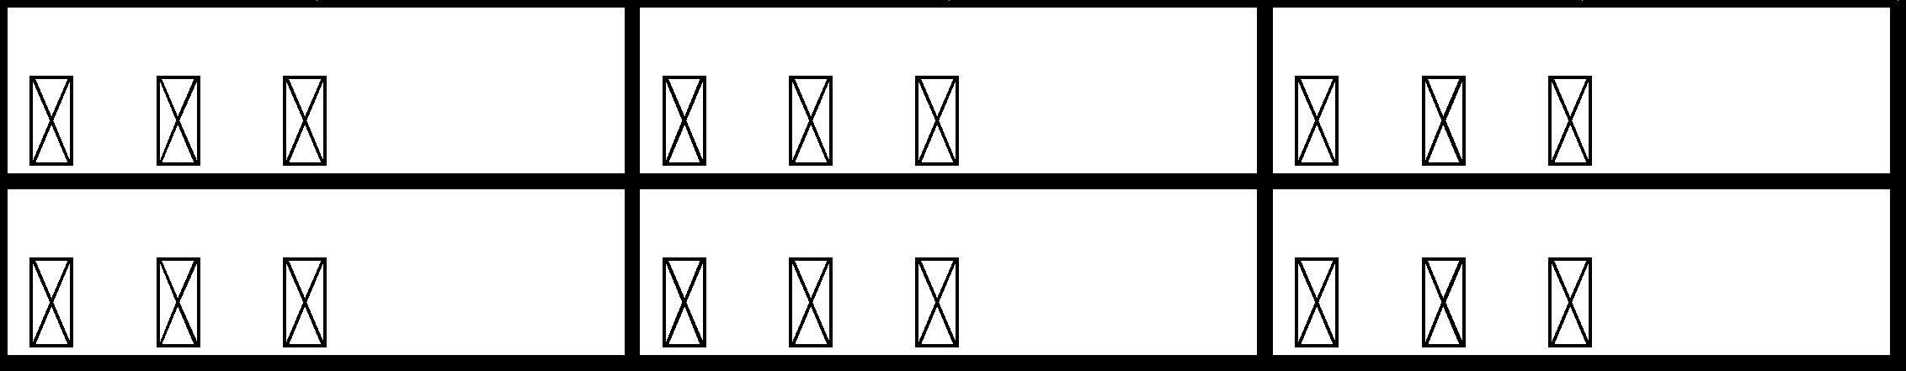  在校  紀錄
1.簡要自述，包含感興趣的STEM領域或正在研究的方向(空間若不敷使用，可另紙書寫)：
2.曾/目前正在參與校內外科學相關競賽、活動、社團(請扼要條列，並檢附相關證明)：

三、請確認是否備妥以下資料，並於左上角裝訂後送至教務處設備組：
□ 獎學金申請表(附件一)
□ 個人資料蒐集、處理及利用同意書(附件二)
□ 上下學期成績單影本
□ 曾/目前正在參與科學相關競賽、活動、社團等證明影本
附件二
個人資料蒐集、處理及利用同意書

您為申請台積電STEM人才培育獎學金（下稱「本獎學金」），將提供台灣積體電路股份有限公司（下稱「台積電」或「本公司」）個人資料，為保障您的權益，本公司謹依個人資料保護法第八條第一項，告知您以下事項。若您於後勾選同意並簽署本同意書，即代表您已充分瞭解本同意書之內容並同意受其拘束：

- 個人資料蒐集之目的
本公司為處理您報名本獎學金相關事宜（包括且不限為報名管理、身分確認、審核活動聯繫等），並將您的資料建檔於本公司人才資料庫等目的，將蒐集、處理、利用您的個人資料。依據法務部「個人資料保護法之特定目的及個人資料之類別」之分類，上述本公司蒐集您個人資料之目的屬「人事管理(002)」、「契約、類似契約或其他法律關係事務(069)」、「教育或訓練行政(109)」、「產學合作(110)」「其他經營合於營業登記項目或組織章程所定之業務(181)」等。

- 個人資料之類別
本公司僅會於本同意書第一條所定特定目的範圍內，蒐集您的個人資料。這些資料包括但不限於您的姓名、身分證字號、學校、電子信箱等可以辨識您本人之資料。依據法務部「個人資料保護法之特定目的及個人資料之類別」之分類，本公司蒐集您的個人資料之類別包括「辨識個人者(C001)」、「政府資料中之辨識者(C003)」、「個人描述(C011)」、「學校記錄(C051)」、「資格或技術(C052)」、「著作(C056)」、「學生（員）、應考人紀錄(C057)」、「工作經驗(C064)」等。

- 個人資料利用之期間、地區、對象及方式
- 本公司將於第一條特定目的範圍內，以電子郵件或其他方式，在中華民國境內或境外蒐集、處理、利用您的個人資料。為達成第一條所列之目的，本公司得傳輸您之個人資料予本公司之從屬/控制公司（依公司法第369條之2之規定），及伺服器提供者等受本公司委託處理您個人資料之第三人。
- 本公司將於本公司經營期間，且本同意書第一條目的尚存續時，利用及處理您的個人資料。

- 您依個人資料保護法所得行使之權利及方式
- 就您提供予本公司之個人資料，您有權向本公司：(1)查詢或請求閱覽；(2)請求製給複製本；(3)請求補充或更正；(4)請求停止蒐集、處理或利用；(5)請求刪除的權利。
- 您依本條第1項約定提出請求時，須檢附相關證明文件向本公司提出書面請求；就您查詢或請求閱覽個人資料或製給複製本時，本公司得酌收必要成本費用。您瞭解，若您要求本公司刪除、停止繼續使用您的個人資料，將可能影響您申請及受領本獎學金之資格。

- 不提供個人資料對您權益之影響
您可以自由決定是否提供您的個人資料予本公司，惟您亦瞭解如不完整提供該等資料，您將無法申請本獎學金。

□我同意並瞭解上述台積電STEM人才培育獎學金個人資料蒐集、處理及利用同意書所有內容，並擔保我所提供予台積電之資料均屬真實正確。

聲明人：___________＿＿＿
身分證字號：___________＿＿＿
通訊地址：___________＿＿＿＿＿＿＿＿＿＿＿＿＿＿＿

